# Simple Mail Transfer Protocol

Simple male transfer protocol is used to transfer email from a sender to receiver via mail server.

Mail server is different from a web server, web server is used to host web pages, whereas mail server is used to transfer email messages between sender and receiver.

**Mail Agent (Mail Reader)** User agent that is used to compose and read messages.

**Mail Transfer Agent (SMTP Server )**Mail server also known as mail transfer agent is a server or a computer system tat is responsible for successful transfer of email message from source to destination.

Email boxes are placed inside mail servers, email server places the incoming emails into their relevant boxes and then transmits them to their desired destinations.

**SMTP Envelope**

It contains SMTP header and body. Header is the sender, receiver address, along with meta-data and body contains actual message.

Header is separated from body by using a blank line.

**Header contains:** Sender, receiver address, subject, MIME properties, and other meta data.

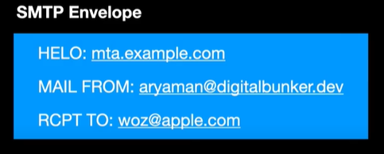

**Body:** Any text proceeding the header is the body of email and it is terminated with pre-defined terminators like blank line, or full stop.

Header is sent separately from the body of the header.

1. SMTP authenticates sender and receiver before sending body (Its like handshaking )
2. Once authenticated, body of the email is sent to the recipient SMTP server.

SMTP is part of application layer and it uses DNS to find the IP address of the SMTP server to setup the connection with the client SMTP server. Sender and receiver SMTP servers are different and their email address format are different.

Outgoing emails are directed to client email server and incoming are received from receiver email servers.

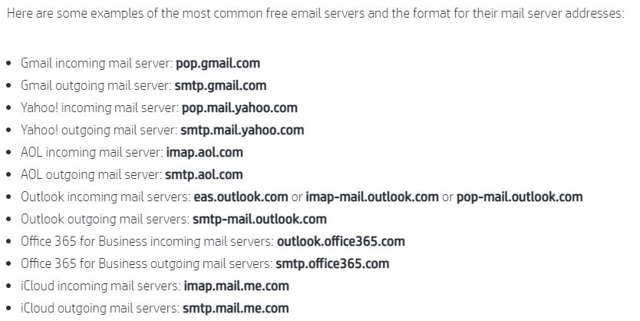

# How SMTP works ?

SMTP request or header is sent in the following format to the recipient mail server.

**HELLO or request message:** This is just a TCP handshaking to let the recipient know about the process which is communicating with it.

**MAIL FROM:** Sender address

**RCPT To:** Receiver address (CC and BCC are specified here)

The above information is sent once per session (TCP connection), once connection is established, the sender can send as many emails as he can without sending this information again with each email. After the above information, next command or part of response message from the client is:

**Data:** It contains body of the email terminated by the pre-defined terminator.

**Quit:** Terminate TCP

Sending emails to SMTP server via PHP:

<https://stackoverflow.com/questions/14456673/sending-email-with-php-from-an-smtp-server>

<https://www.w3schools.com/php/func_mail_mail.asp>

# Mail Access Protocol

SMTP is a push protocol, it can only push an email from client to client-mail-server and from one mail server to another mail server.

Recipient cannot read an email from the receiver-mail-server as reading an email from the receiver-mail-server is a pull operation and it requires some pull protocol like:

* Mail access protocol (Post Office Protocol, Internet Mail Access Protocol)

Mail access protocol like POP3 is used to read email from receiver-mail-server to the receiver user-agent.

POP is a Post Office Protocol, pull protocol used to read emails from server into the user-agent.

POP3 is the version of POP, POP begins when a client’ user-agent like email reader, opens up a TCP connection with the mail server at port#110 . POP3 progresses through three phases:

* Authorization
* Transaction
* Update

During Authorization phase, user-agent builds a TCP connection with the server and requests to access the mailbox on the server, server asks for authentication, the user-agent sends username and password to authenticate the user.

During transaction, the user agent reads the message. User can also perform certain operations on emails during this phase like, marking emails for deletion, moving emails between different folders, obtaining emails statistics.

During Update state, the mail server commits the actions that were specified in the transaction phase. The Update phase occurs when user issues an *QUIT* command. *QUIT* command also ends in termination of TCP connection.

In POP3, user-agent issues a command to the user and user responds to the command by providing a reply.

In POP3 the server communicates with the user-agent by issuing two types of commands:

* *OK* followed by the server to client data
* *ERR* to indicate that there is some problem with the command.

The Authorization phase has two commands:

* User BOB
* Pass ABC123

During the transaction phase, the client orders the server to list messages by their size. The server lists the messages by number. The client access the message by the number.

Client uses four types of commands during the transaction phase:

List, retr, dele, quit

When client issues a quit command, the server enters into the Update state and commits the commands which were specified in the transaction phase.

The POP3 operates on two modes:

* *Download-and-delete*
* *Download-and-keep*

In download and delete mechanism, once an email-agent reads the email from mail server it is deleted but since it is not a good option, we use download and keep mechanism in which the emails are not deleted once they have been read.

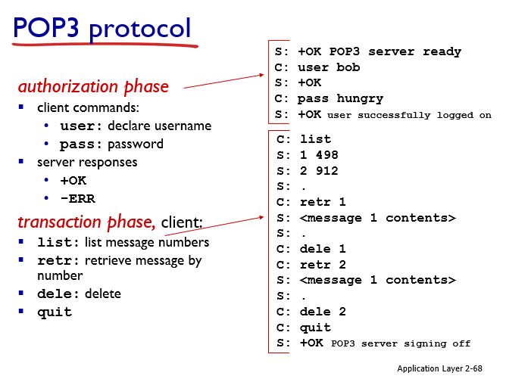

# Limitations of POP3

POP3 downloads messages from email server into client PC. Once emails are downloaded, the are deleted form the server. All the settings that a client do to its email are done on the local machine to which the emails were downloaded. When a user access the emails from other devices, the settings done to the emails will not be visible.

This is not a desired feature for clients.

Therefore we use IMAP.

# Internet Mail Transfer Protocol (IMAP)

Internet mail transfer protocol does not download the emails to the reader machine. It keeps all the emails on server, when a user moves emails between different folders, these emails are actually moved into different folders on server, folders are created on server.

If a user reads an email from multiple devices, he will see the changes on all devices.

Another advantage of IMAP is that , it allows the user to downloads emails in parts. It does not automatically download the attachments which allows the email server to be accessed even at the low bandwidth and low internet speed.

IMAP only downloads the email into our local PC that we have clicked. IMAP keep the email settings on server.

IMAP only downloads a message when you click on it. It does not download attachments automatically whereas web mails never downloads mails into local PC.

# Web Email

Emails are not loaded into email application. All the mails are saved on the mail server. The user access their emails from mail servers via HTTP request.

Sender sends email to mail server via HTTP. Receiver receives email from mail server via HTTP.

But mail from sender mail server to receiver mail server is transferred via SMTP.

# Difference between POP, IMAP, and Web Mail

<https://www.shoppepro.com/support/knowledgebase/292/Difference-between-POP3-IMAP-and-Webmail.html>

# Domain Name System

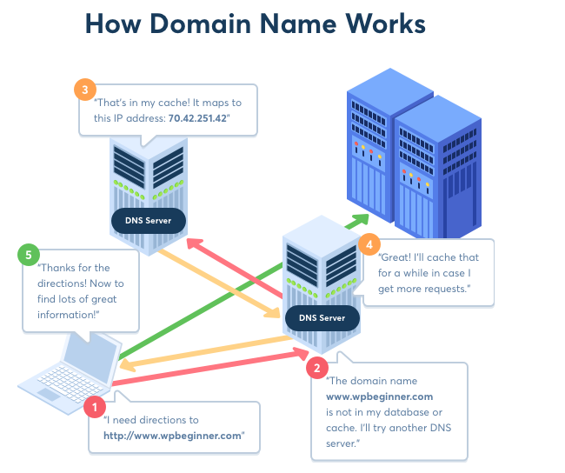

<https://www.wpbeginner.com/beginners-guide/beginners-guide-what-is-a-domain-name-and-how-do-domains-work/>

# DNS Attacks

# Peer to Peer file distribution

In peer to peer file distribution, there is no server. Files are not downloaded or uploaded from servers instead a peer can download parts of different files from different peers. Each pair holds specific part of a particular file, an edge requesting a particular file can access different parts of file from different peers.

A peer runs a peer-to-peer application and as soon as it runs the application, all the peers holding parts of particular file become visible to him, the client can then use FTP to download part of file from any of the peer.

Each peer can redistribute any potion of file it has received to any other peer.

One of the most popular P2P file distribution is Bittorrent. BitTorrent is actually a P2P file distribution protocol.

P2P is self-scalable.

# Example

**Distribution Time in Client Server and Peer-2-Peer networks.**

File distribution time is the time required either to upload or to download a particular file form the server. In the client-server model, the distribution time includes the time required by the server to upload a file , or by a client to download a file.

In P2P network, transmission time is the time required either by the server to upload a file to the peers, or time required by a peer to download a file, or time required by the entire peers and server to upload the file to the required peer.

DCS = Max {NF/Us, F/dmin }

DP2P = Max { F/Us, F/dmin, FM/(Us+∑Ui)}

As the number of nodes in the network increases, the distribution time in the network increases linearly. But in P2P network, distribution time does not increases linearly with the increasing number of clients.

<https://www.youtube.com/watch?v=zzMd19puxwg>

<https://gaia.cs.umass.edu/kurose_ross/interactive/CS_vs_P2P_download.php>

One challenge associated with this approach is how a client knows about which computer is holding part of desired file?

# BitTorrent